Straight Knife Cutting Machine KS-AUV / KS-AUH
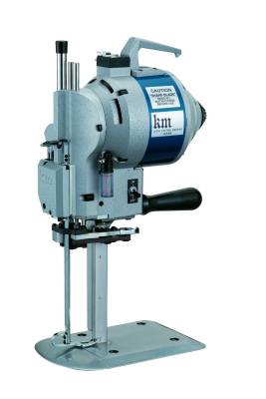
KS-AU, Straight Knife Cloth Cutting Machine with Automatic Abrasive Belts Sharpenner, is the most popular cutting machine in the Garment Industry. It's suitable for cutting all kinds of fabrics from thin materials to thick materials.
■ MOTOR
The Motor is an originally developed Motor. It assures a Smooth Cutting Operation
with Excellent Cutting Power and Low Motor Temperature.
■ AUTOMATIC OIL LUBRICATION DEVICE
Oil can be supplied Automatically from Oil Reservoir to the Guide Metals and Cross
Head. And the Internal oil Guard keeps other Interior parts clean.
■ AUTOMATIC SHARPENING DEVICE
There is an Abrasive Belt Sharpening device. Just press down the Sharpening
lever, and the Blade can be shapened Automatically to maintain the most suitable
Edge of the Blade.
■ STANDARD
Thinner and Flat type Standard makes the Resistance of Cutting ,Material Lower,
and Bigger Blade Stoke makes Cutting Smoothly.
■ BASE PLATE
The Base Plate is Low and Surface is Smooth to make the Materials travel on it
Smoothly before and after Cutting.

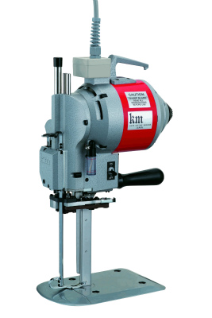
High Power type is also avaiable
Model : KS-AUH
Power : 800W
Voltage : 1P220V

Straight Knife Cutting Machine KS-AUV / KS-AUH
- 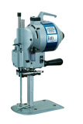

- 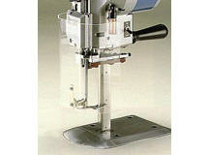
Knife Guard (Optioin）

Model | Cutting Capacity
AUV 6" | 110m/m
AUV 7" | 135m/m
AUV 8" | 160m/m
AUV 10" | 210m/m
AUV 13" | 290m/m
Power | 500W / 800W (KS-AUH)
Voltage | 100V 200V
Weight | 14.5Kg

